SIMATS ENGINEERING (SAVEETHA SCHOOL OF ENGINEERING)
Department of Computer Science and Engineering
CO2 ASSESSMENT TOOL 2 – Architecture Design Assignment

Course Code: | CSA10 / CSA1004 | Course Title: | Software Engineering
CO Assessed: | CO2 | Assessment: | Assessment Tool 2 – Architecture Design Assignment
Weightage: | 20% | Total Marks: | 25
CO2 Statement: | Perform detailed requirements analysis, design scalable architectures, and prioritize features with a focus on cross-disciplinary skills
Student Name: | K Sreelatha | Reg. No.: | 192425248
Date: | 27/11/2026 | Duration: | 60 minutes

Code of Conduct
I __K Sreelatha(192425248)__ (Name / Reg No) certify that this submission is my original work and that I have adhered to the guidelines specified for this assessment. I understand that any violation of academic integrity rules will result in disciplinary action.
Signature of the Student: __Sree K____
Annexure A – Architecture Design Assignment
Instructions to Students:
Each student will be assigned an individual software project problem statement. Based on the assigned problem, analyze the system requirements and design an appropriate software architecture by applying software engineering principles. Your submission should demonstrate your ability to select, justify, and evaluate a suitable architectural style.

Question
Based on your assigned problem statement, perform an Architecture Design Analysis and prepare an architecture design report by answering the following questions:

1. Analyze System Requirements
- Study the given problem statement and identify the system objectives.
- Analyze the functional and non-functional requirements that influence the software architecture.
- Identify key quality attributes such as scalability, maintainability, reliability, availability, performance, and security.

2. Select a Suitable Software Architecture
- Select an appropriate architectural style for the proposed system (e.g., Layered Architecture, Client-Server, MVC, Microservices, Event-Driven, Service-Oriented Architecture, Serverless, or Hybrid Architecture).
- Justify why the selected architecture is the most suitable for the given problem.

3. Draw the Software Architecture Diagram
- Design a clear architecture diagram illustrating the overall structure of the proposed system.
- Include all major layers/components, databases, external systems, APIs, and communication mechanisms.
- Use appropriate software architecture notations and labels.

4. Explain Components and Their Interactions
- Describe the purpose and responsibilities of each architectural component.
- Explain how the components communicate and exchange data.
- Illustrate the overall workflow of the system.

5. Discuss Quality Attributes
Evaluate how the proposed architecture addresses the following aspects:
- Scalability
- Security
- Performance
- Reliability
- Maintainability
- Availability

6. Justify Architectural Decisions
- Explain the rationale behind your architectural choices.
- Discuss the trade-offs considered while selecting the architecture.
- Explain how the chosen architecture supports future enhancements, system integration, and long-term maintainability.
ARCHITECTURE DESIGN ANALYSIS
Intelligent Public Transport Monitoring System
1. Analyze System Requirements
1.1 Introduction
The Intelligent Public Transport Monitoring System is designed to monitor public buses in real time and provide useful information to passengers and transport administrators. The system uses GPS technology to track bus locations, estimate arrival times, monitor occupancy, manage routes, and identify delays.
The proposed system aims to improve passenger convenience, transportation efficiency, and bus fleet management.
1.2 System Objectives
The main objectives are:
- Track bus locations in real time using GPS.
- Provide estimated bus arrival times to passengers.
- Display bus routes and schedules.
- Monitor passenger occupancy.
- Detect bus delays and send notifications.
- Help administrators manage buses and routes.
- Generate reports for transportation authorities.
1.3 Functional Requirements
Functional requirements describe what the system must do.
ID | Functional Requirement
FR1 | Allow users to register and log in.
FR2 | Track bus locations in real time.
FR3 | Calculate estimated arrival times.
FR4 | Display bus routes and schedules.
FR5 | Monitor passenger occupancy.
FR6 | Allow drivers to update trip status.
FR7 | Allow administrators to manage buses.
FR8 | Allow administrators to manage routes and schedules.
FR9 | Detect delays and send notifications.
FR10 | Generate transportation reports.
1.4 Non-Functional Requirements
Non-functional requirements describe the quality and performance expected from the system.
- Scalability: The system should support increasing numbers of buses and passengers.
- Security: User information and system data must be protected.
- Performance: Bus locations and arrival estimates should be updated quickly.
- Reliability: The system should provide accurate information and handle failures appropriately.
- Availability: The system should remain accessible during operating hours.
- Maintainability: Developers should be able to update and maintain individual components easily.

2. Select a Suitable Software Architecture
2.1 Selected Architecture: Layered Client-Server Architecture
The proposed system uses a Layered Client-Server Architecture.
In this architecture, the system is divided into different layers, with each layer responsible for specific tasks. Passengers and administrators access the system through client applications, while a central server processes requests and communicates with the database and external services.
The architecture consists of five main layers:
- Presentation Layer
- Application Layer
- Business Logic Layer
- Data Access Layer
- Data Layer
GPS services and notification services interact with the appropriate backend components.
2.2 Justification for Selecting This Architecture
The Layered Client-Server Architecture is suitable for the following reasons:
- Separation of concerns: Each layer has a clearly defined responsibility.
- Easy maintenance: Changes to the user interface can be made without redesigning the entire system.
- Security: Authentication and authorization can be managed centrally.
- Scalability: Server resources can be increased as the number of users grows.
- Data management: Bus locations, routes, schedules, and occupancy records can be stored systematically.
- Integration: GPS devices and notification services can be connected through APIs.
This architecture is easier to design, understand, test, and maintain than a complex microservices architecture for an initial implementation.
3. Software Architecture Diagram
The architecture diagram represents the major components of the system and how they communicate.
Draw the following structure in draw.io (diagrams.net).
Architecture Diagram Structure
PASSENGER APP ADMIN WEB APP
| |
+-------------+--------------+
|
v
PRESENTATION LAYER
|
HTTP / HTTPS
|
v
APPLICATION SERVER
|
v
BUSINESS LOGIC LAYER
+----------------+----------------+
| | |
v v v
Bus Tracking Route and Notification
Service Schedule Service
| Service |
v | v
GPS Service | Push / SMS API
| |
+----------------+
|
v
DATA ACCESS LAYER
|
v
DATABASE
+----------------+----------------+
| | |
v v v
Bus Data Route Data Location Data
|
v
Occupancy Data
Note: This is a simplified logical architecture. In the final diagram, show the database as one component containing separate data categories rather than drawing a separate database for each category. Draw GPS as an external system connected to the Bus Tracking Service.
The final diagram should contain:
- Passenger Mobile Application
- Administrator Web Application
- Presentation Layer
- Application Server
- Business Logic Layer
- Bus Tracking Service
- Route and Schedule Service
- Notification Service
- Data Access Layer
- Database
- External GPS Service
- External SMS/Push Notification API
Use rectangles for components, a cylinder for the database, and arrows to show the direction of communication.

4. Explain Components and Their Interactions
4.1 Presentation Layer
This layer provides the interface through which passengers, drivers, and administrators interact with the system.
Responsibilities:
- Display bus locations and routes.
- Show estimated arrival times.
- Display occupancy information.
- Provide administrative dashboards.
- Accept user input.
4.2 Application Server
The application server receives requests from client applications and forwards them to the appropriate backend components.
Responsibilities:
- Handle client requests.
- Coordinate backend operations.
- Return responses to users.
- Communicate with the business logic layer.
4.3 Business Logic Layer
This layer implements the main rules and operations of the system.
It contains the following components:
A. Bus Tracking Service
- Receives GPS location data.
- Processes and updates bus locations.
- Provides current bus positions to users.
B. Route and Schedule Service
- Stores and retrieves bus routes.
- Maintains schedules and stop information.
- Supports estimated arrival time calculations.
C. Occupancy Monitoring Service
- Processes passenger occupancy information.
- Maintains current occupancy records.
- Provides occupancy information to passengers and administrators.
D. Notification Service
- Detects events that require notifications, such as delays.
- Sends notifications through an external SMS or push notification API.
4.4 Data Access Layer
This layer acts as an intermediary between the business logic and the database.
Responsibilities:
- Retrieve stored information.
- Insert new records.
- Update bus locations and schedules.
- Ensure consistent database access.
4.5 Database
The database stores the system's persistent information.
It contains:
- User details
- Bus details
- Route and bus-stop information
- Bus schedules
- GPS location records
- Passenger occupancy records
- Delay information
- Notification records
4.6 External GPS Service
The GPS service provides location information for buses. The Bus Tracking Service processes the received information and updates the database.
4.7 External Notification API
An external SMS or push notification service delivers alerts to users when delays or other important events occur.
4.8 Component Interaction Workflow
The system works as follows:
- A bus sends its location through a GPS-enabled device.
- The Bus Tracking Service receives and processes the location data.
- The Data Access Layer updates the location information in the database.
- A passenger opens the mobile application and requests the location of a bus.
- The request passes through the Application Server to the relevant business logic component.
- The component retrieves the latest information through the Data Access Layer.
- The server returns the bus location and estimated arrival time to the passenger.
- If a significant delay is detected, the Notification Service can send an alert through the external notification API.

5. Discuss Quality Attributes
5.1 Scalability
The architecture supports increasing numbers of passengers, buses, and requests. Additional server resources can be allocated as demand increases. Frequently accessed route and schedule information can also be cached.
5.2 Security
The system uses authentication to verify users and role-based authorization to control access. HTTPS protects data during transmission. Sensitive information should be protected through appropriate encryption, secure credentials, and access controls.
5.3 Performance
The system retrieves bus locations and route information through backend services. Database indexing and caching can reduce response times. Location updates should be processed efficiently to provide timely information.
5.4 Reliability
The system validates incoming GPS data and handles temporary communication failures. Location updates can be retried when appropriate. Database backups help recover information if data is lost.
5.5 Maintainability
The layered design separates the user interface, business logic, and data access. Developers can modify or test one component without making unnecessary changes to other components.
5.6 Availability
The system can improve availability through server monitoring, database backups, health checks, and recovery mechanisms. Redundant servers can be introduced if higher availability is required.
Note: These are proposed architectural measures. They must be implemented and tested before the system can be claimed to meet specific performance or availability targets.

6. Justify Architectural Decisions
6.1 Rationale Behind Architectural Choices
The Layered Client-Server Architecture was selected because the system needs a centralized method of processing requests from passengers and administrators while managing bus tracking, route information, and notifications.
Separating the system into layers makes it easier to understand, develop, test, and maintain.
The architecture also supports integration with external GPS and notification services.
6.2 Architectural Trade-Offs
Advantages:
- Simple and understandable structure.
- Clear separation of responsibilities.
- Easier testing and debugging.
- Centralized security and data management.
- Supports future enhancements.
Limitations:
- If the central application server fails, several functions may become unavailable unless redundancy is provided.
- Heavy traffic can increase the load on shared components.
- Changes to shared backend components may affect multiple functions.
- Real-time location tracking requires reliable communication and efficient data processing.
6.3 Future Enhancements
The architecture can be extended with the following features:
- AI-based arrival time prediction.
- Smart passenger occupancy detection.
- Integration with traffic monitoring systems.
- Mobile applications for Android and iOS.
- Cloud deployment to support increasing demand.
- Predictive maintenance for buses.
- Analytics dashboards for transportation authorities.
6.4 Conclusion
The Intelligent Public Transport Monitoring System requires an architecture that supports real-time information processing, secure data management, integration with external services, and future growth.
The Layered Client-Server Architecture provides a suitable foundation by separating presentation, business logic, and data access responsibilities. It supports maintainability, security, performance optimization, and scalability while keeping the initial system manageable.
Therefore, the proposed architecture is appropriate for developing an intelligent public transport monitoring solution.
Output:
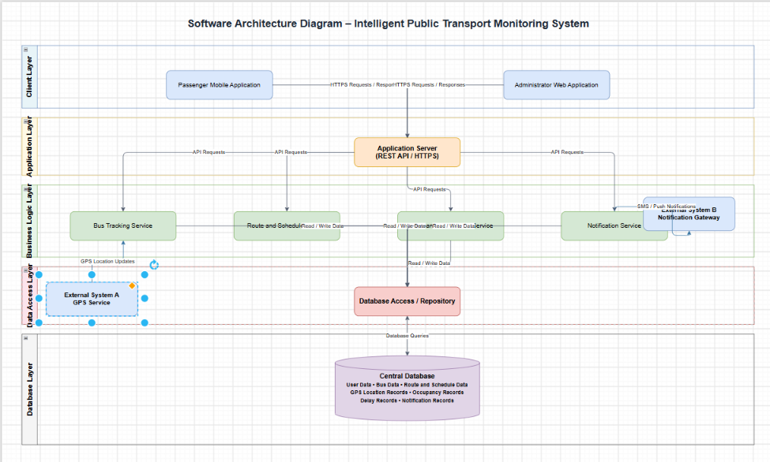

Rubrics for Calculation
Evaluation Criteria | Excellent (4 Marks) | Good (3 Marks) | Satisfactory (2 Marks) | Needs Improvement (1 Mark)
System Requirement Analysis (30%) | Thoroughly analyzes the problem statement, accurately identifies functional and non-functional requirements, and clearly explains quality attributes influencing the architecture. | Analyzes most requirements with minor omissions or limited explanation. | Identifies only basic requirements with partial analysis. | Requirement analysis is incomplete, inaccurate, or lacks clarity.
Selection of Software Architecture (25%) | Selects the most appropriate architectural style with strong technical justification aligned to system requirements. | Selects a suitable architecture with reasonable justification. | Architecture is partially suitable with limited justification. | Inappropriate architecture selected or justification is missing.
Architecture Diagram and Component Design (20%) | Produces a clear, complete, and well-structured architecture diagram with all major components, interfaces, and interactions accurately represented. | Diagram is mostly complete with minor omissions or notation issues. | Diagram includes only essential components and lacks sufficient detail. | Diagram is incomplete, unclear, or technically incorrect.
Component Interaction and Quality Attribute Analysis (15%) | Clearly explains component responsibilities, interactions, and thoroughly discusses scalability, security, performance, reliability, maintainability, and availability. | Explains most components and quality attributes with minor gaps. | Provides limited explanation of interactions and addresses only some quality attributes. | Component interactions and quality attributes are poorly explained or missing.
Architectural Justification and Technical Presentation (10%) | Provides strong justification for architectural decisions, discusses trade-offs and future enhancements, and presents a well-organized, professional report. | Provides adequate justification with minor gaps; report is well organized. | Limited justification with minimal discussion of trade-offs or future scope; report needs improvement. | Justification is weak or absent; report lacks organization and technical clarity.

Criteria | Mark
System Requirement Analysis (30%) | /5
Selection of Software Architecture (25%) | /5
Architecture Diagram and Component Design (20%) | /5
Component Interaction and Quality Attribute Analysis (15%) | /5
Architectural Justification and Technical Presentation (10%) | /5
TOTAL | /25

